Overview
- Install
- Configure
- Test
- Use

Install
- Install extension into Magento

sendAcknowledgement=true

Configure
Configuration requires some knowledge of EDI document format. The contents of the EDI document is controlled by the configuration of a document definition file. The file contains all the instructions to the program on what information goes on each line of the EDI document. The provided document definition file will generate a valid 850. However, every implementation of EDI will have specific requirements that will require some changes to the document definition file.

The configuration of the document definition file closely mirrors that of the X12 standard transaction set documentation for each functional group.

Line Definition Section

The line definition (shown below) defines each data segment. In the example below, it defines the ST data segment.

1  2  3  4  5  6  7  8  910  11  12  13  14  15  16  17 | <lineDefinition>  <recordType>ST</recordType>  <columnDefinition>  Column definition xml goes here  </columnDefinition>  <required>true</required>  <min>1</min>  <max>1</max>  <group>3</group>  <parentGroup>2</parentGroup>  <level>2</level>  <order>1</order>  </lineDefinition>

Element | Description
recordType | 2 or 3 letter code for the segment
columnDefinition | Definition for each element of the segment
required | true or false indicating if this segment is required.
min | Minimum number of times the segment must occur in the document
max | Maximum number of times the segment can occur in the document
group | A number indicating a group this segment belongs to. Segments in the same group appear together in the document
parentGroup | The number of the group preceding this group. Used to enforce the order groups appear
level | The number of the level this segment appears. Used to enforce a segment always following another
order | Used to enforce the order an element appears within a group
orderDetailLoop | When true indicates the segment will repeat for each item on the order
shipmentLoop | When true indicates the following segments will repeat for each shipment
shipmentLineLoop | When true indicates the following segments will repeat for each shipment line
productLoop | Set to true on each segment that repeats for each product
inventoryLoop | When true indicates the following segments will repeat for each inventory item
shipmentDetailLoop | When true indicates the segment will repeat for each item on a shipment

Shipment Detail Loop operation

Has a conditional filter to only read the lines that contain the filter field with the filter value.

1  2  3  4  5  6  7  8  910 | <shipmentDetailLoop>  <value>true</value>  <conditional>  <filter>  <fieldName>HierachicalLevelCode</fieldName>  <fieldValue>I</fieldValue>  </filter>  </conditional>  </shipmentDetailLoop>

Column Definition section

The column definition defines the characteristics of each element of a segment

1  2  3  4  5  6  7  8  910  11  12  13  14  15  16  17  18  19  20  21  22 | <column>  <position>0</position>  <fieldName>Element</fieldName>  <type>A</type>  <minLength>2</minLength>  <maxLength>2</maxLength>  <required>M</required>  <fixedValue>ST</fixedValue>  </column>  <column>  <position>1</position>  <fieldName>TransactionSetIdentifierCode</fieldName>  <type>ID</type>  <minLength>3</minLength>  <maxLength>3</maxLength>  <required>M</required>  <fixedValues>  <fixedValue>C310</fixedValue>  <fixedValue>D240</fixedValue>  </fixedValues>  </column>

Element | Description
position | Beginning at 0 indicates the position of the element across the document
fieldName | A unique name identifier used in reporting errors. Must be unique within each segment
type | A code describing the type of data in the element (ID, A, AN or NO)
minLength | Minimum width of the text in this element
maxLength | Maximum width of the text in this element
required | A code indicating if text is required in this element (Optional: O, Mandatory: M, Conditional: C)
fixedValue | Text that will always occur in this element
fixedValues | Contains multiple fixedValue tags. Used when a segment may appear multiple times but have different values each time
orderValue | Name of a Magento order field containing the text to put in this element
ackValue | Name of a ack field where the value in this element will be saved to send with the document's corresponding acknowledgment
orderValues | Contains multiple orderValue tags. Used when a segment may appear multiple times but have different values each time
orderDetailValue | Name of a Magento order detail field containing the text to put in this element
shipmentDetailValue | Name of a Magento shipment detail field containing the text to put in this element
testValue | When testing, this data will be placed in this element
testValues | Contains multiple testValue tags. Used when a segment may appear multiple times but have different values each time
calculatedValue | The name of a function used to put text in this element
productValue
productValues | Contains multiple productValue tags. Used when a segment may appear multiple times but have different values each time
inventoryValue
calculatedValues | Contains multiple calculatedValue tags. Used when a segment may appear multiple times but have different values each time

of Navigate to the app/code/local/Dhtechnologies/Ediconnectorbase directory and open the Edi850DocumentDefinition.xml file

CalculatedValue list
InterchangeControlNumber | Returns a new sequential number each use
NowDate | Returns the current date in the format YYMMDD
NowTime | Returns the current time in the format hhmm
NowLongDate | Returns the current date in the formate CCYYMMDD
NowLongTime | Returns the current time in the format hhmmss
Level2Count | A count of all the items in level 2
Level1Count | A count of all the items in level 1

productValue
Sku
Name
Description
ShortDescription
Weight
Price

InventoryValue
Sku
Quantity

ackValue list
FunctionalIdCode | Functional id code
GroupControlNumber | Group control number
AcknowledgeCode | The acknowledgement code
TransactionSets | Transaction set number

OrderValue list
RealOrderId | Order number
ShippingDiscountAmount
ShippingAmount
ScacCode | SCAC code
ShippingAddress/Name
BillingAddress/Name
ShippingAddress/Street1
BillingAddress/Street1
ShippingAddress/Street2
BillingAddress/Street2
ShippingAddress/City
BillingAddress/City
ShippingAddress/RegionCode | State or province
BillingAddress/RegionCode
ShippingAddress/Postcode
BillingAddress/Postcode
ShippingAddress/Country
BillingAddress/Country
NumberItems
OrderGrandTotal

orderDetailValue
ItemNumber
QtyOrdered
Price
Sku

shipmentDetailValue
Sku
QuantityShipped

shipmentValue
ScacCode
TrackingNumber
OrderNumber

shipmentLineValue
TrackingNumber
QuantityShipped
ProductNumber

Configuration and Setup

Login to their admin
Go to system → configuration
Select edi connector from left menu
Select general
It should look something like this:
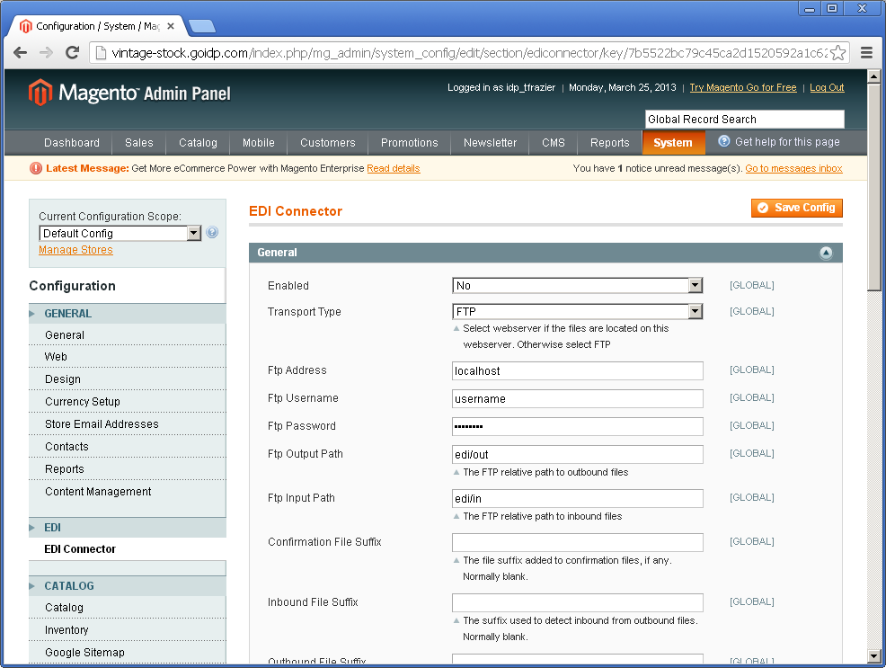

Set enabled to yes
Enter FTP Address, Username, Password, Output path, and Input path
Address: myediftpaddress.com
Username: joe
Password: supersecret

NOTE the input uses the OUTBOUND and the output uses the INBOUND

Input Path: /pub/EDI/OUTBOUND/850
Output Path: /pub/TESTEDI/INBOUND
Unless given specific instructions to do otherwise, most options should be left at their defaults

Then click Save Config

It should look something like this:

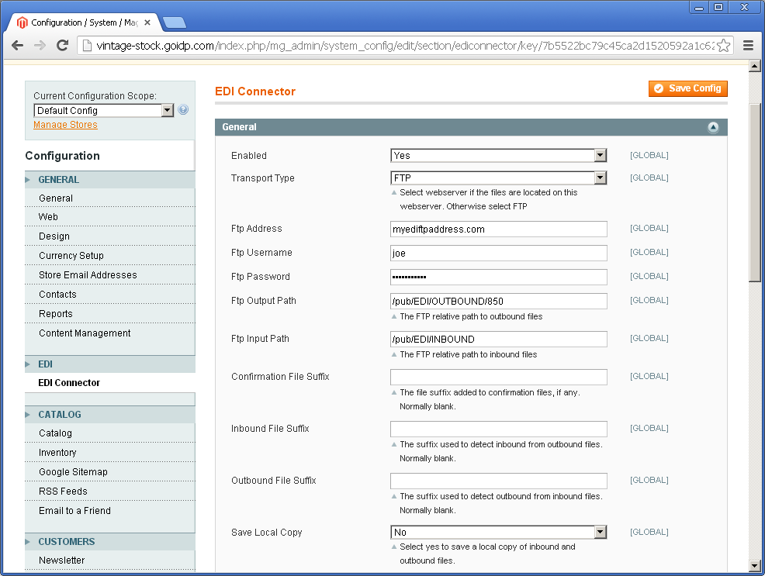

For the EDI end of line delimiter, use a hex editor like Free Hex Editor Neo. You are looking for the characters that are at the end of every line. This should let you see what the corresponding hexadecimal characters are.
It should look something like this:

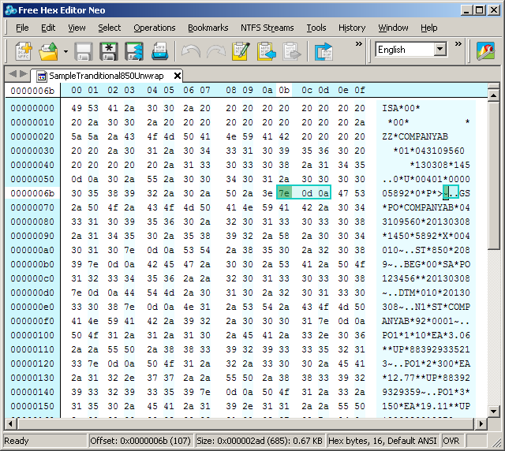

In this example, you would enter 7e0d0a

The field separator in this example is the character *

Record type element is typically the default value. It is the element that says what kind of document it is.
Record type column is also typically the default value. It is the column number that has the document type in it.
For example:
ST*850*2089~
In this example, the record type is ST and the column is 1.

The date and time format used is the same syntax as what PHP uses. Documentation for this can be found on php.net for more specific information.

Open the document 850 out and enable by selecting yes. As seen in the image below.

Also, don't forget to Save Config

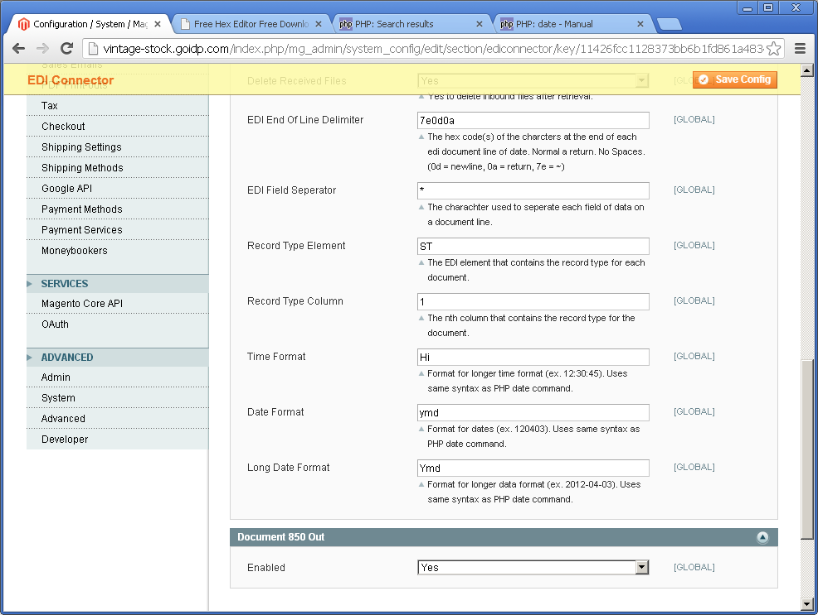

To test the connection, use the following command from command line:
php app/code/local/Dhtechnologies/Ediconnectorbase/Model/Tester.php -n

To see any errors, go to System → Notifications
It should look something like this:

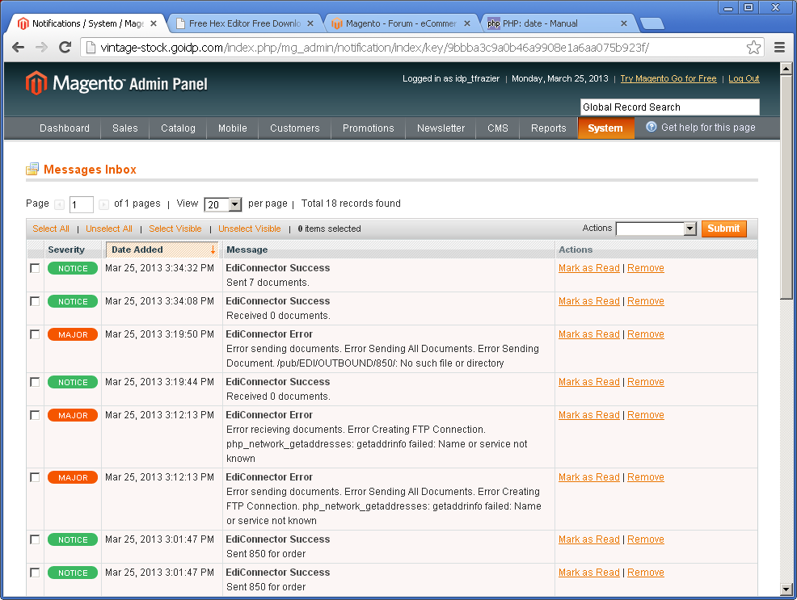

Or you can view the log file from the command line with the following command:
less var/log/ediconnector.log

If you edit the file: app/code/local/Dhtechnologies/Ediconnectorbase/etc/Edi850DocumentDefinition.xml
Then you must delete the session and cache with the following command in command line:
rm -rf var/session/ var/cache

For the scheduling to work properly, you will need to setup a cron job. This is done in command line.

You will need to Add cron job to crontab like:
*/5 * * * * /bin/sh /home/someuser/www/magento/cron.sh

In this example, it will set up the scheduling to run every 5 minutes.

